Patient Demographics
Province | % | n
Alberta | 0.30% | 1
British Columbia | 9.58% | 32
Manitoba | 5.09% | 17
Maritime Provinces: New Brunswick, Nova Scotia, Prince Edward Island, Newfoundland and Labrador | 0.00% | 0
Ontario | 85.03% | 284
Quebec | 0.00% | 0
Saskatchewan | 0.00% | 0
Age
Mean | 72.6 (SD 16.2)
Median | 76
Gender
Female | 41.52% | 137
Male | 58.48% | 193
Other | 0.00% | 0
Patient self-identified ethnicity, race or other special populations
White | 52.08% | 175
Black or African Canadian | 5.95% | 20
Asian | 11.31% | 38
Arab | 1.19% | 4
West Asian / Middle Eastern | 8.63% | 29
Native Canadian / Aboriginal / First Nations /Original peoples of this land | 1.49% | 5
Vulnerably housed, homeless | 1.49% | 5
Incarcerated/Prison inmate | 0.00% | 0
Unknown or prefer not to answer | 3.57% | 12
East Indian | 11.31% | 38
Hispanic | 2.98% | 10
Primary Life-Threatening illness
None (patient was previously well with no serious illness) | 8.50% | 35
Cancer (solid tumor) | 12.86% | 53
Cancer (Hematological) | 3.88% | 16
Cardiovascular | 17.23% | 71
Pulmonary | 10.44% | 43
Gastrointestinal | 1.94% | 8
Hepatology | 1.46% | 6
Renal | 7.28% | 30
Dementia | 11.65% | 48
Neurological (includes Neuromuscular or non-dementia diagnoses) | 7.04% | 29
Infectious | 1.70% | 7
Trauma | 0.97% | 4
Vascular | 2.67% | 11
Metabolic/Endocrine | 2.18% | 9
Genetic/ Chromosomal | 0.00% | 0
Hematology (non-cancer) | 0.49% | 2
Frailty | 8.25% | 34
Unknown | 0.24% | 1
Substance Abuse | 1.21% | 5
Status of life-limiting illness before COVID
Remission or stable | 29.09% | 96
Minimal progression or low disease activity | 26.06% | 86
Moderate disease progression or activity | 25.76% | 85
Severe or high disease progression or activity | 18.79% | 62
Unknown | 0.30% | 1
Patient COVID Outcome
COVID infection Resolved | 49.09% | 161
Patient Died | 50.91% | 167

Location and Type of Care Provided
Location of Care
Hospital- General Floor | 59.39% | 196
Hospital - ICU (includes MICU, SICU, TICU, CICI, Neuro ICU, PICU) | 22.73% | 75
Emergency Department | 0.30% | 1
Outpatient Clinic | 3.64% | 12
Long term Care | 5.45% | 18
Palliative Care Unit or Hospice | 1.21% | 4
Retirement Home/Assisted Living Facility | 1.52% | 5
Home | 3.33% | 11
Other | 2.42% | 8
Virtual Care Technologies
Telehealth | 5.92% | 19
In-person | 88.79% | 285
Mix of both | 5.30% | 17
COVID Treatment
No treatment except symptomatic management | 6.45% | 61
Supplemental oxygen | 27.48% | 260
Medications including Remdesivir, antivirals, antimalarial, IL-6 inhibitors, IVIG, plasma, those in clinical trials, etc. | 21.14% | 200
Hospitalization | 26.43% | 250
ICU Admission | 8.88% | 84
Ventilation | 7.82% | 74
ICU Admission for High flow Oxygen not intubation/ECMO | 1.80% | 17
Palliative Care Provided
Physical Symptom Management | 29.17% | 299
Psychosocial support to patient | 24.29% | 249
Decision Making (includes Goals of Care) | 24.29% | 249
Providing support to family | 21.76% | 223
Other | 0.49% | 5
Discharge Location
Hospital | 6.83% | 11
Long term Care | 9.32% | 15
Palliative Care Unit or Hospice | 8.07% | 13
Retirement Home/Assisted Living Facility | 5.59% | 9
Home | 51.55% | 83
Other | 18.63% | 30
Location of Death
Hospital- General Floor | 45.78% | 76
Hospital- ICU (includes MICU, SICU, TICU, CICI, Neuro ICU, PICU) | 40.36% | 67
Emergency Department | 0.00% | 0
Long term Care | 4.22% | 7
Palliative Care Unit or Hospice | 4.22% | 7
Retirement Home/Assisted Living Facility | 0.60% | 1
Home | 3.61% | 6
Other | 1.20% | 2

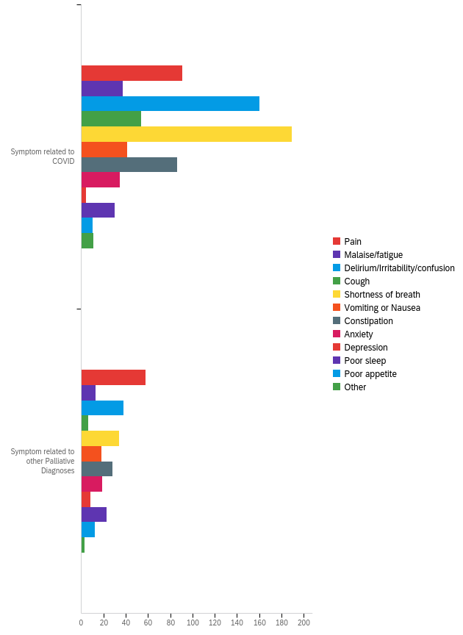
Palliative Medications Used in Managing Patients
Medications Used | Started |  | Titrated |  | Stopped |  | Total
Morphine/Hydromorphone | 70.17% | 167 | 28.57% | 68 | 1.26% | 3 | 238
Oxycodone | 16.67% | 1 | 50.00% | 3 | 33.33% | 2 | 6
Fentanyl /Sufentanil | 84.44% | 38 | 11.11% | 5 | 4.44% | 2 | 45
Midazolam | 77.55% | 38 | 16.33% | 8 | 6.12% | 3 | 49
Other benzos (lorazepam, diazepam) | 73.13% | 49 | 22.39% | 15 | 4.48% | 3 | 67
Phenobarbitol | 0.00% | 0 | 0.00% | 0 | 0.00% | 0 | 0
Methotrimeprazine | 81.25% | 52 | 18.75% | 12 | 0.00% | 0 | 64
Loxapine | 0.00% | 0 | 0.00% | 0 | 0.00% | 0 | 0
Haloperidol | 79.01% | 64 | 16.05% | 13 | 4.94% | 4 | 81
Olanzapine | 100.00% | 1 | 0.00% | 0 | 0.00% | 0 | 1
Quetiapine | 95.65% | 22 | 0.00% | 0 | 4.35% | 1 | 23
Glucocorticoids | 90.22% | 83 | 7.61% | 7 | 2.17% | 2 | 92
NSAIDs | 100.00% | 1 | 0.00% | 0 | 0.00% | 0 | 1
Glycopyrronium or Scopolamine | 91.53% | 54 | 6.78% | 4 | 1.69% | 1 | 59
Senna or other laxatives | 90.70% | 39 | 9.30% | 4 | 0.00% | 0 | 43
Palliative Sedation | 58.33% | 7 | 41.67% | 5 | 0.00% | 0 | 12
Other | 86.73% | 85 | 11.22% | 11 | 2.04% | 2 | 98

Factors Affecting Care
Medication Shortages | % | n
Yes | 1.23% | 4
No | 98.77% | 320
Factors that affected location of care:
Speed of patient deterioration | 10.79% | 45
Lack of ACP/GoC ie goals of care clarity | 13.19% | 55
Availability of PPE | 0.96% | 4
Availability of medications | 0.72% | 3
Availability of home care support | 17.75% | 74
Availability of family/caregivers | 26.14% | 109
Access to PCU or hospice placement for COVID positive patients | 6.95% | 29
Restrictive institutional visitation policies | 23.50% | 98
Factors that affected Location of Death
Speed of patient deterioration | 13.67% | 35
Lack of ACP/GoC ie goals of care clarity | 16.41% | 42
Availability of PPE | 0.00% | 0
Availability of medications | 0.39% | 1
Availability of home care support | 12.11% | 31
Availability of family/caregivers | 23.44% | 60
Access to PCU or hospice placement for COVID positive patients | 15.63% | 40
Restrictive institutional visitation policies | 18.36% | 47
Do you believe the patient received goal-concordant care?
Definitely yes | 46.04% | 151
Probably yes | 43.90% | 144
Might or might not | 7.93% | 26
Probably not | 1.83% | 6
Definitely not | 0.30% | 1

